Software Design Documentation
Product Name | Grevol VCU
Date Updated | 09-Nov-25
Written By | Prathamesh Patki

Introduction
The purpose of this document is to provide a comprehensive overview of the software design for the Grevol VCU firmware. This includes the system overview, design considerations, specifications, detailed design, implementation plan, testing plan, and maintenance plan.

System Overview
The Grevol VCU is a vehicle controller that acts as a master co-ordinating the activities with other systems in the vehicle. It interfaces with battery monitoring modules and functions as a battery manager that ensures the safety of the battery and controls to enhance the battery life. It implements the vehicle controls to allow the interface to motor controller to enhance the driving experience. It interfaces to the telematics device to send the vehicle and battery parameters to cloud.
The embedded software shall be built in C for target microcontroller STM32G0B1CETx using the STM32Cube IDE.

Design Considerations
- Modular architecture to allow for porting to different microcontroller
- Configurability to allow interfaces to different BMS and MCU devices
- Easy and secure software updates
- Scalability to allow additional computations and features

Design Specifications
Below is the block diagram of the VCU with its interface components:
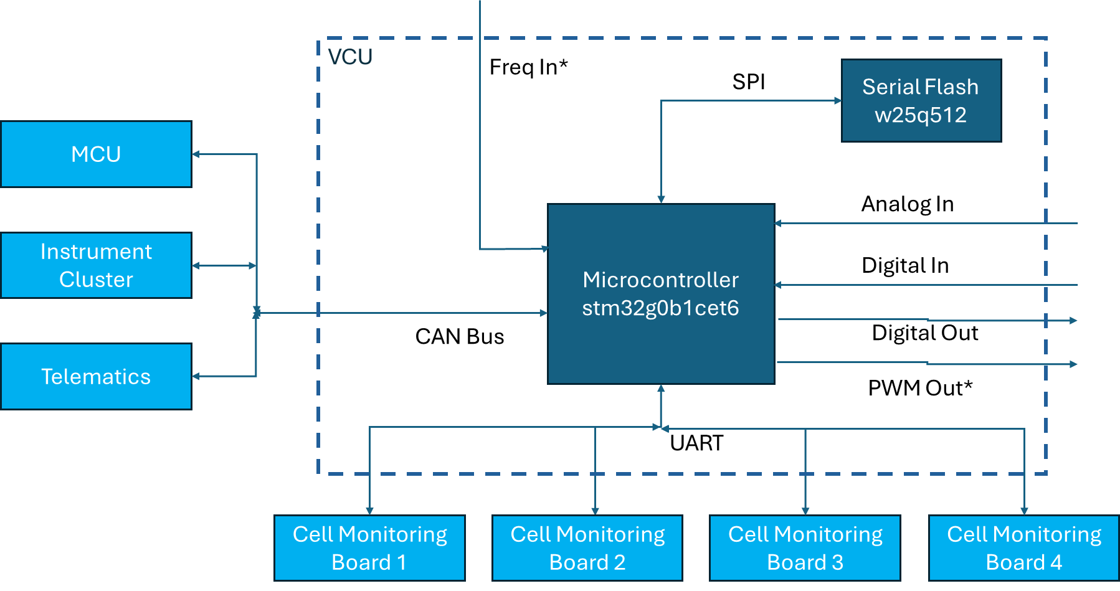
Hardware Software Interface
Below is the microcontroller chip pinout structure:
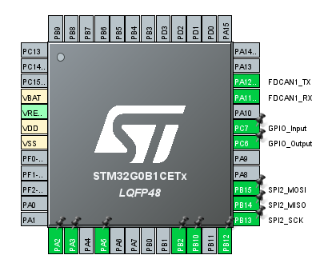
Below table lists the microcontroller pin mapping along with the pin type:
UC Pin | Signal | Type
PA14 | Brak- brake pressed | GPIn
PA13 | Ing – ignition in | GPIn
PA12 | Dirc – drive direction | GPIn
PA11 | Cont-contactor out | GPOut
PA10 | Urx – uart rx | UART RX
PC7 | Park – parking in | GPIn
PC6 | brkre – braking resistor out | GPOut
PA9 | Utx – uart tx | UART TX
PA8 | F3-fan 3 out | GPOut
PB15 | Adio-buzzer out pwm | PWM Out
PB14 | Son-24W supply ctrl | GPOut
PB13 | Sdr1-7W supply ctrl | GPOut
PB12 | Dcon – DC-DC ON | GPOut
PB11 | Gr01 – gear out1 | GPOut
PB10 | Gr02 - gear out 2 | GPOut
PB2 | AD10 – leakage LL | ADC In
PB1 | Fire – fire alarm | GPOut
PB0 | AD9 – leakage HL | ADC In
PA7 | AD8 – 12v supply v sense | ADC In
PA6 | AD7 – batt internal current – 20A max | ADC In
PA5 | AD6 – dcdc con out | ADC In
PA4 | Ad5 – throttle in | ADC In
PA3 | Ci – charging current (400A) | ADC In
PA2 | Disi – discharging curr (400A) | ADC In
PC13 | Pre- precharge out | GP out
PC14 | OSCIn 32khz
PC15 | OSCou 32khz
VBAT
VRE
VDD
VSS
PF0 | F1- fan 1 out | GPOut
PF1 | F2 – fan2 out | GPOut
PF2 | nrst
PA0 | Vbs-batt v before contactor(77.5V) | ADC In
PA1 | Vls-battv after contactor | ADC In
PB9 | Grin2 – gear in? | GPIn
PB8 | Grin1 – gear in? | GPIn
PB7 | Mode- fwd-rev | GPIn
PB6 | TRC – PWMOut Throttle | PWM Out
PB5 | MOSI- SFLASH | SPI
PB4 | MISO- SFLASH | SPI
PB3 | SCK- SFLASH | SPI
PD3 | NSS – SFLASH | GPOut
PD2 | Clutch out | GPOut
PD1 | FDCTX– CAN | CAN
PD0 | FDCRX-CAN | CAN
PA15 | TAC – speed in/ Freq In | Freq In
Note: Appendix 1 has the details received from the hardware team about the operation
Module Requirements
Device Driver Interface
D1 The software shall read the analog signals at 10ms rate and apply the filters as needed
D2 The software shall read digital inputs at 10ms rate and apply appropriate debounce logic
D3 The software shall setup CAN module as per below configuration
Baud rate: 250 kbps, Receive interrupt with filtering, STD and EXT ids
D4 The software shall set digital outputs at as once per execution cycle at the end of application processing
D5 The software shall interface the S-FLASH through SPI and have a shadow memory concept so that the actual writes to the flash are optimized
D6 The software shall interface to the multiple cell monitoring module through UART as per the defined protocol mentioned in Appendix 2 – Baud rate 115 kbps
D7 The software shall set a PWM signal at x kHz frequency and allow for varying duty cycle
D8 The software shall read a frequency input signal in the range 0 hz to y kHz
D9 The device driver functions shall be layered in such a way that the software can be ported or in-parallel configured for anther microcontroller
D10 The software shall detect power supply issue to the op-amps so that the analog data can be marked as invalid for usage
D11 The software shall have calibration and offset correction routines for analog inputs during power ON or at defined intervals
D12 The software shall have memory checks done at defined interval to detect any memory corruption
D13 The software shall allow for software updates using UART and/or CAN
D14 The software shall detect for a valid s-flash and read or write failures
D15 The data in the s-flash shall be in compact/zipped format so that maximum information can be stored
D16 The various task execution rates shall be monitored using watchdogs etc. to maintain the timings and avoid task overruns
D17 The interrupt routines shall be executed for shortest of times and the various priorities to be defined appropriately
D18 The communication failures for CAN and UART shall be detected and can recover automatically
Battery Management
B1 The software shall communicate with the multiple cell balancing modules on UART based on their IDs and get the cell voltage and temperature data
B2 The software shall help in balancing the cells earlier by turning on the balancer based on past data
B3 The software shall read the battery pack voltage before and after the contactor within 1% accuracy
B4 The software shall read the sum of all the cell voltages in series and consider it as battery pack voltage to compare with direct voltage measurements
B5 The software shall read the charging and discharging current values within 1% accuracy
B6 The software shall turn on the pre-charge relay before turning on the main contactor
B7 The software shall estimate the SOC of battery using coulomb counting method and consider capacity as per SOH%
B8 The software shall estimate the SOC of the battery using EKF method
B9 The software shall estimate the SOH of the battery within 5% accuracy
B10 The software shall communicate with specified multiple chargers as per their respective CAN protocols and allow for battery charging within specified limits
B11 The software shall always maintain the cell voltages within their specified minimum and maximum limits
B12 The software shall detect various BMS faults and take appropriate actions as per the table mentioned in Appendix 3
B13 The software shall allow for maximum 95% DOD as per the battery capacity
B14 The software shall define charge current limit (CCL) and discharge current limit (DCL) based on temperature and SOC
B15 The software shall set buzzer as a warning in case of over temperature and thermal runaway conditions
B16 The software shall turn on the DC-DC converter after turning on the main contactor
B17 The software shall automatically recover from fault condition except in cases of safety critical faults where an ignition cycle will be required
B18 The software shall send the BMS parameters on CAN as per the following CAN matrix
(*BMS CAN Matrix table)
B19 The constant variables storing the various setpoint logics shall be separately configurable
B20 If any cell voltage is below minimum allowed threshold, battery shall be considered as deep-discharged and shall be allowed to be charged by a valid charger and at reduced charging current to bring the charge back up.
B21 The software shall set the DCL/CCL based on Cell imbalance to delay cell UV/HV protections
Vehicle Control Unit
V1 The software shall set the optimum torque and speed demands to the MCU so that we get efficient motoring and regeneration performance and best efficiency from the vehicle
V2 The software shall track the vehicle parameters like odometer, vehicle efficiency, charge and discharge energy, trip kms, distance to empty
V3 The software shall detect various VCU faults and take appropriate actions as per the table mentioned in Appendix 4
V4 The software shall store the data parameters and faults in the s-flash which can be later extracted back for debugging purpose
V5 The software shall read the forward/reverse and eco/boost mode status and control the vehicle performance through MCU (motor control unit) accordingly
V6 The software shall send the VCU parameters on CAN as per the following CAN matrix
(*VCU CAN Matrix table)
V7 The constant variables storing the various setpoint logics shall be separately configurable
V8 The software shall inhibit the driving when charger is connected
V9 The software shall read the ignition input and enable the drive after the precharge is done and battery voltage is available on the inverter bus
V10 The software shall adjust the torque/power demand such that the inverter current is maintained within battery Discharge Current Limit and Charge Current Limit. In case of overshoot overcurrent faut to be detected and motoring to be stopped
V11 The software shall indicate a warning when the SOC goes below 10% and set to limp home mode when the SOC is below 5%
V12 The software shall be able to control torque/power demand to limit speed to a defined setpoint with 5% allowed variation.
V13 The software shall be able to control the torque power demand to limit acceleration to defined setpoint with allowed 5% variation.
V14 The software shall limit the Torque/power demand based on the motor,gearbox and inverter temperatures in order to control the temperature rise.
V15 The torque demand/power demand for motoring shall be mapped to the throttle percentage based on the ECO or BOOST modes.
V16 The torque demand/power demand for regeneration shall be set based on throttle release and brake pressed condition
V17 The acceleration/maximum speed setpoints shall be controlled in ECO mode so that the energy consumption is minimized
V18 The software shall get the vehicle location and be able to inhibit the vehicle driving based on defined geo-fencing maps
Telematics
T1 The software shall interface with the telematics module over CAN and allow a two-way communication as per defined protocol
T2 The data packet size being sent to the telematics device shall be optimized by size by data compression algorithms

Detailed Design
Battery Management
The various modes of the battery management module are as follows
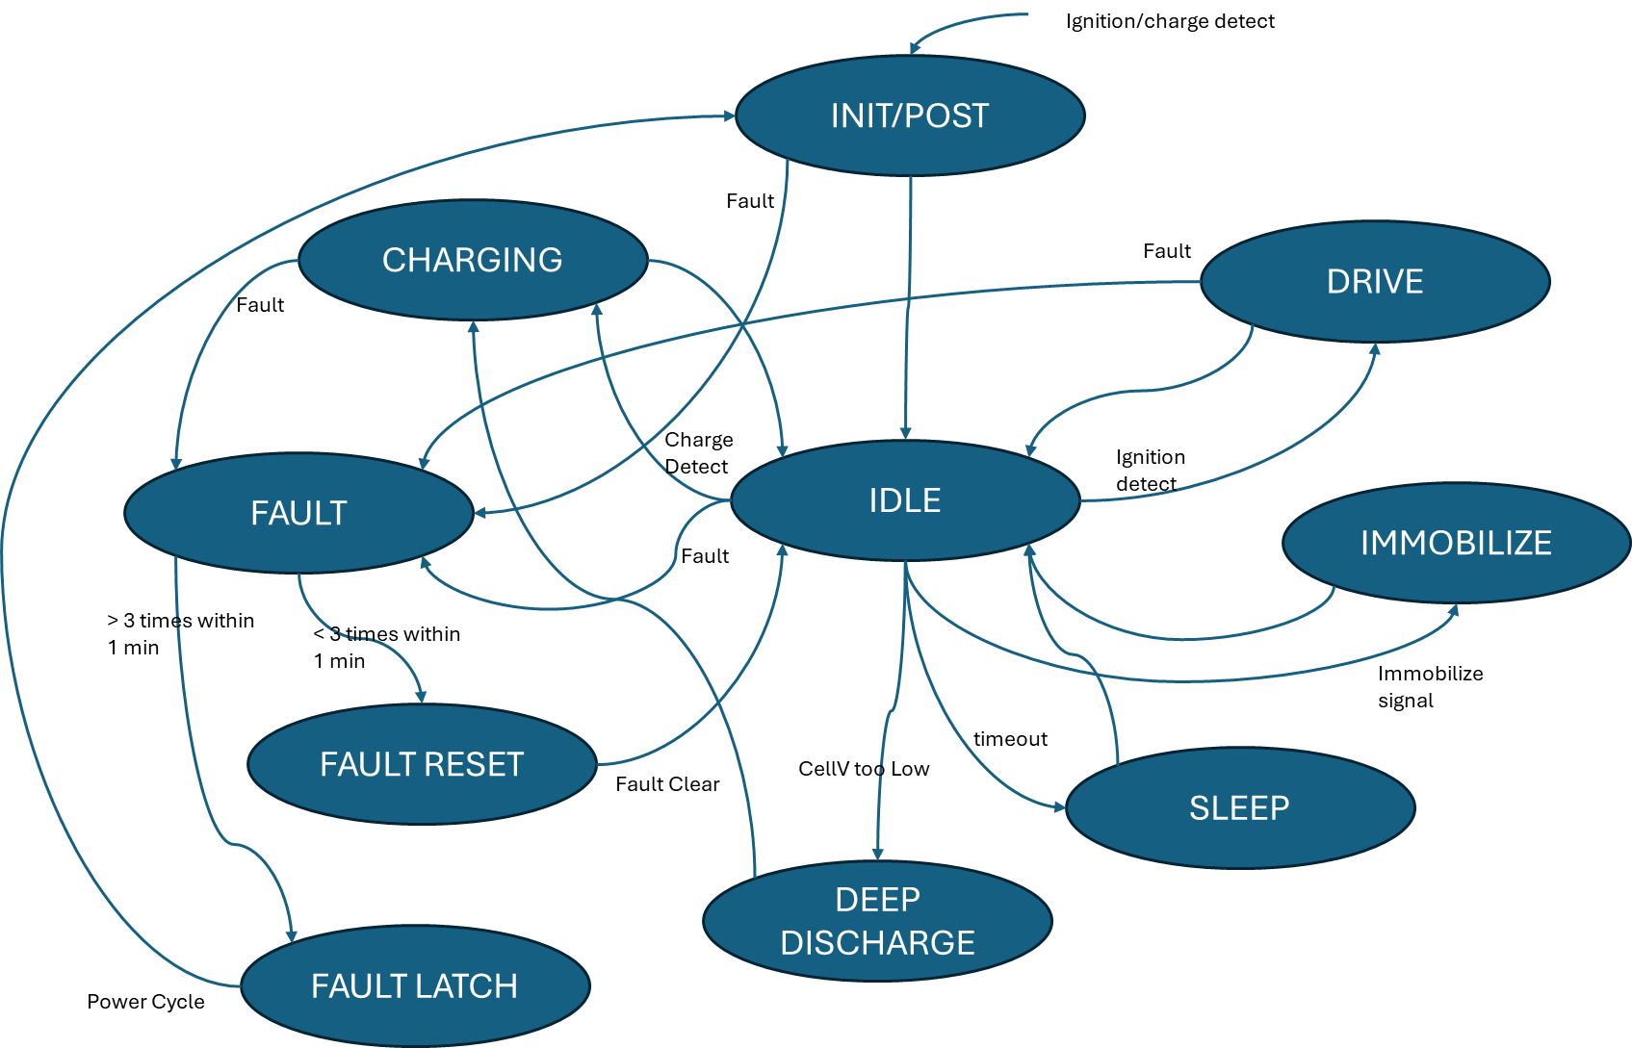

INIT/POST: On a power-up, the BMS software shall be in INIT/Power-On Self Test (POST) mode where it will initialize the device drivers, variables and execute the calibration and self-test routines.
IDLE: IDLE shall be the default mode of the BMS software in normal operation where it will check for the conditions to go into other modes
DRIVE: When the vehicle ignition is ON the BMS software shall be in DRIVE mode. The vehicle shall be allowed to be driven in this mode. In this mode the battery output shall be enabled.
CHARGING: When charger is connected and valid charger messages are received the BMS software shall be in CHARGING mode. This mode shall have higher priority than drive mode. In this mode the battery output shall be enabled.
IMMOBALIZE: When immobilize command is received through telematics device the BMS software shall be in IMMOBALIZE mode. In this mode the battery output shall be disabled.
DEEP-DISCHARGE: When the min cell voltage is below the minimum allowed threshold and a valid charger is connected, the BMS software shall be in DEEP-DISCHARGE mode. The charging current shall be limited to a lower value until the battery comes out of deep discharge state.
FAULT: If any critical fault is detected the BMS software shall go to FAULT mode and disconnect the output. It shall capture a copy of the dataset during the fault before trying a fault reset.
FAULT RESET: Soon after going into FAULT mode the BMS software shall go into FAULT reset mode where it clears the fault automatically and closes back the contactor.
FAULT LATCH: If any fault is triggered thrice within a span of 1 minute, the fault shall be latched. Turning the ignition OFF and back ON shall bring the BMS software out of this mode.
SLEEP: When the BMS software is in IDLE state for long time, it shall move into SLEEP mode where it shall be in low power mode by disabling the peripherals. In this mode it shall communicate with the telematics device at hourly intervals to send the status. It shall come out of the SLEEP mode whenever there is an external activity like ignition ON or charger connected.
Charging Sub-modes:
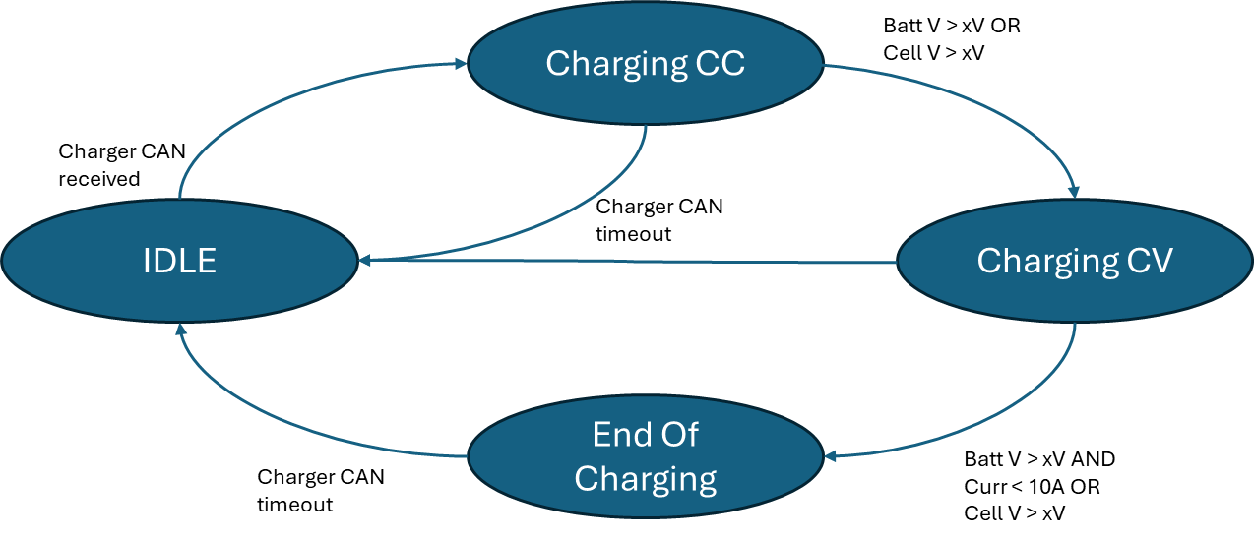
IDLE: This is the default charging sub mode.
Charging CC: When charger broadcast CAN message is received, the mode shall be changed to Charging CC – constant current. In this mode the current demand shall be constant and voltage shall be allowed to rise until the max CV limit. The mode changes back to idle if the charger CAN messages stop.
Charging CV: When the voltage reaches the max CV limit, the mode shall be Charging CV. The current demand shall be reduced so that the voltage stays within the max limit. The mode changes back to idle if the charger CAN messages stop.
End of Charging: When the current gets deduced to a certain limit to maintain the max voltage, the mode shall be End of Charging. The mode changes back to idle when CAN message from charger are stopped.
Vehicle Controller
The various modes of the vehicle controller module are as follows
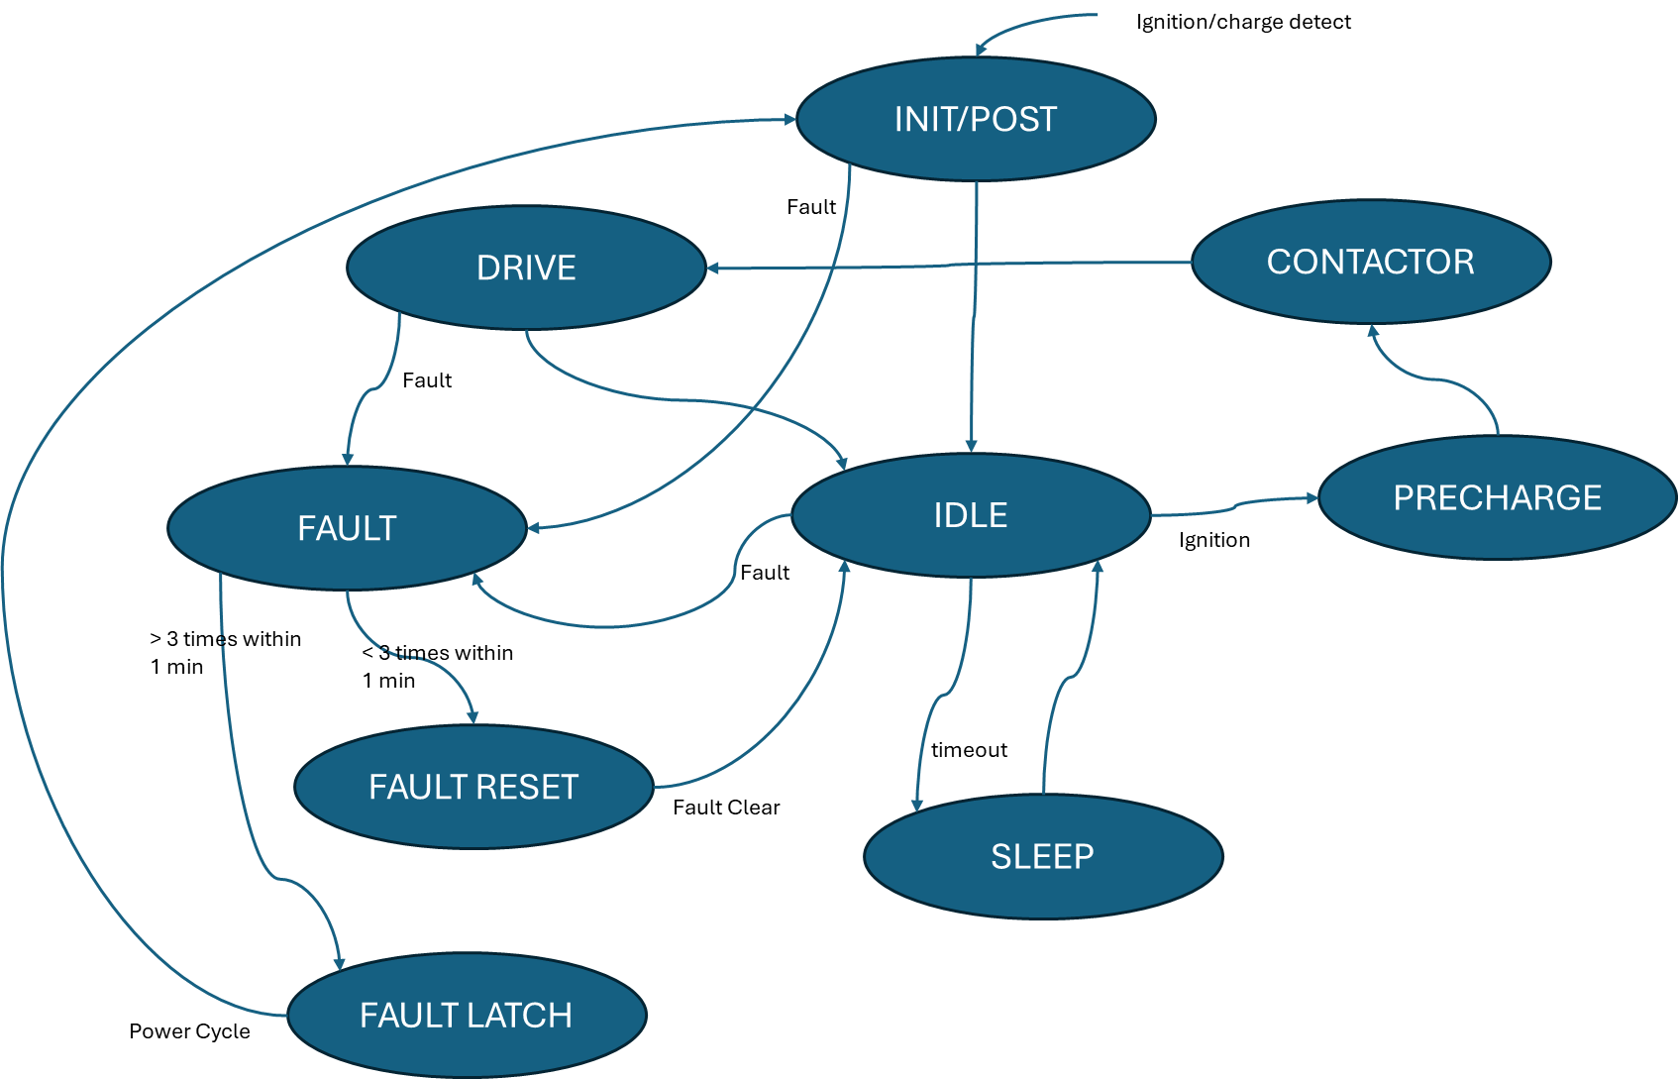

INIT/POST: On a power-up, the VCU software shall be in INIT/Power-On Self Test (POST) mode where it will initialize the device drivers, variables and execute the calibration and self-test routines.
IDLE: IDLE shall be the default mode of the VCU software in normal operation where it will check for the conditions to go into other modes
PRECHARGE-CONTACTOR-DRIVE: Whenever ignition is turned ON or charger is connected, the mode shall be switched in the sequence PRECHARGE (precharge relay is turned ON) – CONTACTOR (precharge relay is turned off and contactor is turned on) – DRIVE (ready to drive)
IMMOBILIZE: In DRIVE mode if immobilize command is received through telematics or charger is connected the VCU mode shall be IMMOBALIZE where vehicle shall not be allowed to move.
FAULT: If any critical fault is detected the VCU software shall go to FAULT mode and disconnect the battery output, or disable the motor controller. It shall capture a copy of the dataset during the fault before trying a fault reset.
FAULT RESET: Soon after going into FAULT mode the VCU software shall go into FAULT reset mode where it clears the fault automatically and closes back the contactor, or enables the motor controller.
FAULT LATCH: If any fault is triggered thrice within a span of 1 minute, the fault shall be latched. Turning the ignition OFF and back ON shall bring the VCU software out of this mode.
SLEEP: When the VCU software is in IDLE state for long time, it shall move into SLEEP mode where it shall be in low power mode by disabling the peripherals. In this mode it shall communicate with the telematics device at hourly intervals to send the status. It shall come out of the SLEEP mode whenever there is an external activity like ignition ON or charger connected.
VCU Drive States
The various mode in VCU drive mode are:
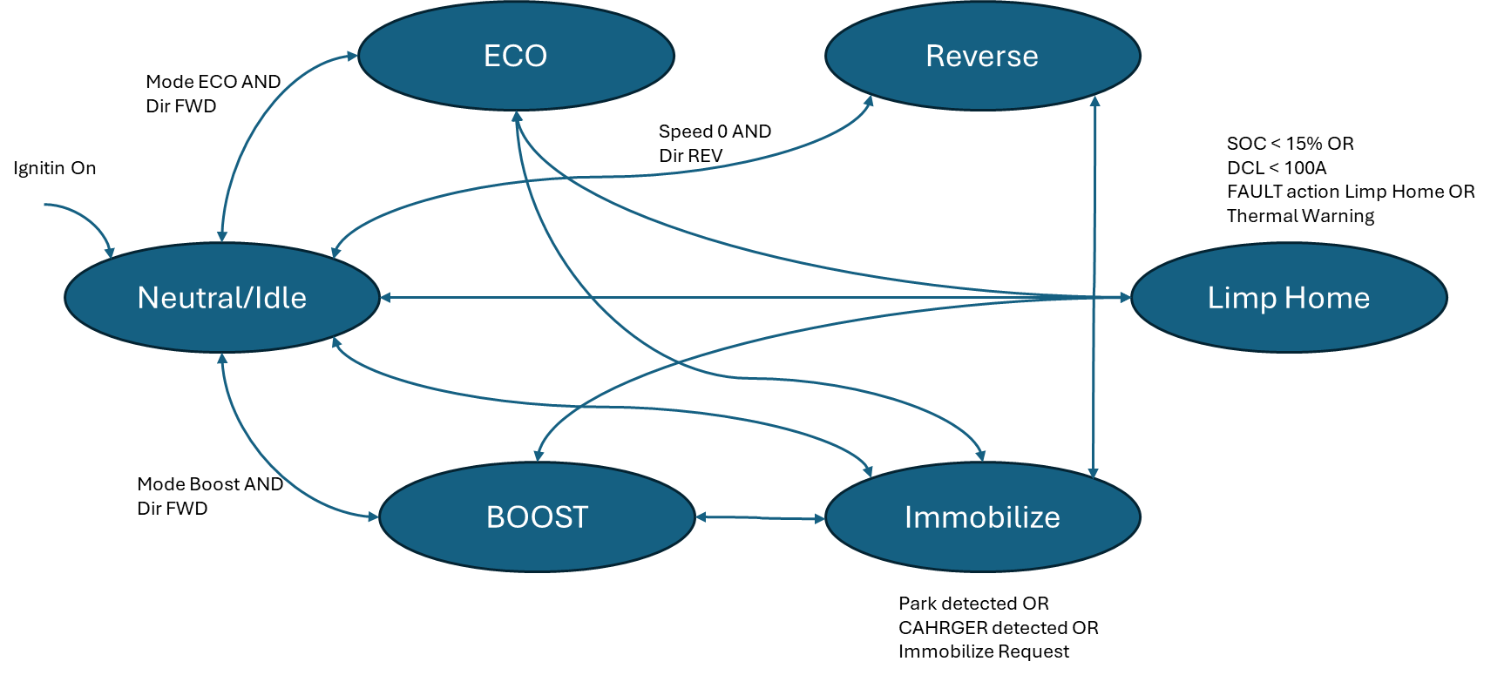
Neutral/Idle: On entering the VCU Drive mode after Ignition ON, the mode shall be Neutral/Idle. In this default mode checks to move to other modes are done, and returns back to this mode. The vehicle is not driveable in this mode.
ECO: When the direction switch is FWD and the mode switch is ECO the mode shall be ECO. Form this mode we can change to Neutral/Idle, Limp home or immobilize. In this mode the speeds and acceleration and controlled to give the best possible vehicle efficiency.
BOOST: When the direction switch is FWD and the mode switch is Boost the mode shall be BOOST. Form this mode we can change to Neutral/Idle, Limp home or immobilize. In this mode the maximum speed and power shall be allowed to give the best power performance.
Reverse: When the vehicle speed is 0 and direction switch is REV the mode shall be Reverse. In this mode the vehicle drives in reverse direction with speed limited to less than 7 to 10kmph.
Immobilize: When charger connected is detected or park brake is pressed or immobilize is command is received from server, the mode shall be Immobilize. The vehicle is not allowed to be driven in this mode. The mode can be changed to this from ECO-Neutral-Boost.
Limp Home: When SOC is low or there is a thermal warning or the is a fault defined to move to limp home mode or DCL is low due to any condition the mode shall be Limp Home. In this mode the vehicle speed shall be limited to a low value so that the driver is indicated to take the vehicle to a stop at the earliest possible place. The mode can be changed to this from ECO-Neutral-Boost.

Implementation Plan
Task | Assigned To | Start Date | End Date | Status

Testing Plan
- Unit testing for individual components on STM Evaluation board by simulating the interfaces
- Integration testing for different modules on the final target hardware
- Performance testing to ensure scalability and responsiveness

Maintenance Plan
The maintenance plan includes regular updates, bug fixes, and feature enhancements based on user feedback. The plan also outlines the process for handling support requests and ensuring system availability.
Signatures:
Project Manager: ___________________________________________
Lead Developer: ____________________________________________

Conclusion
This software design documentation provides a comprehensive overview of the Grevol VCU firmware design. It includes the system overview, design considerations, specifications, detailed design, implementation plan, testing plan, and maintenance plan. Any revisions to this document will be recorded below.
Revisions:
Version | Date | Author | Description
1.0 | 16-10-2025 | Prathamesh Patki | Initial version
1.1 | 09-11-2025 | Prathamesh Patki | Added updates based on review meeting 1-Nov

Appendix 1

Code controls regarding operation of hardware
- adc uses internal 2.5 volt reference. All analog circuits give max output of 2.5 v. for keeping margin for overshoots at nominal values inputs to adc may be lower. Will require a routine to caliberate card testing time.
- Diagnostic mode testing for all i/o .
- Supply management: system has 3 supplies.
  - A low current linear supply that powers the cpu during sleep state and boot strap the main supply. Max drain .007 ma.
  - A 7w self oscillating supply that provides isolated power for the can bus and iot device. And 5v to power up the on board ics. The supply is controlled by signal sdr1 ( sdr1 is active low) . in bang bang mode or pwm mode such that 8<v12<10v. this supply is to be used for periodic wake up activities. An isolated source to sense the ignition switch is also provided.
  - A 24w main supply is provide for regular operation . the output of this supply are ored with the outputs of the 7w supply. Hence the 7w supply will go off. Control is by signal( son) output voltage regulated by supply ic 12v +/- 1v. code may have a monitor on this voltage to detect a fault condition. Supply voltage sensed on (AD8)
  - Current consumption is available . (AD7) to be used to modify battery discharged ah. And also to determine if a peripheral is activated or not. Max sensing is 20amp. Can be changed by changing resistance r80 and r98. Max amp = 2.5 *R100/r98/(r177//r178//r182//r185). Monitored for over current sensing.
- Signal dcon connects the dcdc converter ground to the battery ground . hence enabling the same.

DC ON active high with weak pull down. Valid only after main contactor turned on+delay. If after dcon is high and VLS drops detect contactor failure.
- DCDC converter output monitored for failure/ short circuit sensed on (AD6)
- VBs senses the battery voltage = 2.5 volts for 77.5 volt dc input if zero check fuse f1.
- VLS senses voltage after the contactor. Data used to control precharge signal pre active low. Configure pin with pull up. CONT used to activate contactor , active low with internal pull up.
- Power supply testing . to test voltage regulation, for max load condition, noload condition , current consumption , input dc variation.card has two power supplies. A 24w supply, and and a 7w supply.
- 24 w supply is current mode controlled. Has a on/off switch driven by the cpu .
- Leakage test if no leakage HL(AD9) and LL (AD10) will be equal . (tolerance +/- 5%) else there is leakage error condition to be set after a filter duration . cont=0 and pre = 0 sound alarm .?? how to handle reset of this error and what should be frequency of this test.??
- DISI discharging current max value 400 amp. CI charging current max value 400 amps to account for regen current.
- Throttle input sensed on (AD5). Max value 5v. throttle value sent to motor controller can be regulated through PWM output (TRC) pwm freqecy 4khz. This converted to an anlog value and sent to the MCU
- Digital output:
  - Gr01 and gr02 grear change output currently not used.
  - Fire alarm for battery temp fire. ?? if set how to be cleared alo what actions to be taken??
  - F1,f2,f3 for controlling fan etc or any other device these signal have low pull down enabled and are active high only valid after DCDC converter is active.
  - ADIO is a buzzer output may be a pwm signal to output different frequency if supported by the buzzer.
  - Brke =1 if VBS > a setpoint and =0 if vbs < setpoit – hyterysis or any cell > 3.8 till < 3.7.
  - NSS signal shared with memory spi . keep high , set low to clear spi reset spi buffer in memory and also give external signal to charger.
- Input
  - Ing signal active high to register key switch. Have a dead band between successive switch operations. On valid ING=1 SON =1 check v12 if V12 okay , start process to connect battery to vehicle bus thru contactor , if VLS okay start DCDC supply check VS+(dcdc output).
  - Read MODE; CLUT( clutch pressed optional);DIRC (drive direction); brak (brak pressed this is active low) suitable take action.
  - TAC pulsed wave form pulses per second and duration of pulse with give shaft RPM.

Appendix 2
Cell Monitoring Module Protocol
Battery Module has CAN IC connected at UART Port.
Protocol Used is not CAN.

Data to Module (Transmitter):
- Set Interrupt at 1.25mS.
- No Matter what Byte has to be transmitted at exactly 1.25mS Interval. This is for ADC Synchronization of all Modules
- At the end of byte transmission accept receiver byte if any
- Every 8th Byte (10mS) has to be 252. This is independent of transmission Packet status.
- When No Transmission Packet is required keep sending 254 (Accept for 8th byte which will always remain 252)
- When Transmission packet is to be sent, Send it instead of 254 (8th byte still remains same)
- (Optional) When Emergency Response is desired Send All module IDs 1 by 1 as (ID<<1)+128. Module will respond single byte (ID<<1)+128 in case of any temperature or voltage error.

Data from Module (Receiver):
Module will send 1 data byte after receiving byte at every 1.25mS

Packet Structure:
- Communication from UART port is at pre-defined Baud Rate, 8 bit & No parity.
- Baud Rate presently 19.2 KHz will be changed to 115.2 KHz
- Data is Binary.
- Uses 7- Bit Communication where 1st Byte of Packet will always have LSB = 0 & all other bytes of Packet will have LSB = 1.
- MSB of all bytes are shifted out & sent as separate byte. After every 7 bytes of data 8th byte inserted is 7 MSB bits of previous 7 bytes.
- Last 3- Bytes of Packet are CRC. (16-Bit packed in 7-bits with 8th bit LSB = 1)
- CRC is computed for all Bytes transmitted or receive accept CRC bytes

Packet from Module
- Module ID<<1
- Data Type<<1+1 (Data Type defines Packet size & its contents)
1<<1+1 Normal Packet type
Normal Packet type contents:
- Status<<1+1 (MSB in bit B7 of MSB byte)
- Errors<<1+1 (MSB in bit B6 of MSB byte)
- Errors of V<<1+1 (MSB in bit B5 of MSB byte)
- Temperature 01<<1+1 (MSB in bit B4 of MSB byte)
- Internal<<1+1 (MSB in bit B3 of MSB byte)
- Temperature 2<<1+1 (MSB in bit B2 of MSB byte)
- VSOC0<<1+1 (MSB in bit B1 of MSB byte)
- 8th bits of above bytes in (MSB Byte | 1) (B7.B6.B5.B4.B3.B2.B1.1)
- VSOC1<<1+1
- VSOC2<<1+1
- VSOC3<<1+1
- Cell0 mV HIBYTE<<1+1
- Cell0 mV LOBYTE<<1+1
- Cell1 mV HIBYTE<<1+1
- Cell1 mV LOBYTE<<1+1
- 8th bits of above bytes in (MSB Byte | 1) (B7.B6.B5.B4.B3.B2.B1.1)
- Cell2 mV HIBYTE<<1+1
- Cell2 mV LOBYTE<<1+1
- Cell3 mV HIBYTE<<1+1
- Cell3 mV LOBYTE<<1+1
- Internal<<1+1
- Internal<<1+1
- 8th bits of above bytes in (MSB Byte | 1) (B7.B6.B5.B4.B3.B2.B1.1)
- Internal<<1+1
- Internal<<1+1
- Internal<<1+1
- Internal<<1+1
- Valid Cell counts in module<<1+1
- 8th bits of above bytes in (MSB Byte | 1) (B7.B6.B5.B4.B3.B2.B1.1)
CRC is computed for all of the above Bytes
- CRC LOBYTE<<1+1 (MSB in bit B1 of MSB byte)
- CRC HIBYTE<<1+1 (MSB in bit B2 of MSB byte)
- CRC 8th Bits (MSB Byte | 1) (0.0.0.0.0.B2.B1.1)
**Caution Packet bytes are Big Endian & MSB bit of 1st byte is at right.
CS byte is Little Endian and MSB bit LOBYTE is at right)

Standard Query Packet to Module (module will respond only after receiving it’s ID)
Send Following data to get Data from specified Module

- Module ID<<1
- 129
- CRC LOBYTE<<1+1 (MSB in bit B1 of MSB byte)
- CRC HIBYTE<<1+1 (MSB in bit B2 of MSB byte)
- CRC 8th Bits (MSB Byte | 1) (0.0.0.0.0.B2.B1.1)

Before Asking Each Module individually it is recommended to send following packet to Trigger Average All Modules Cell Voltages
- (63<<1)
- (5<<1)+1
- 1
- 1
- 1
- 1
- 1
- CRC LOBYTE<<1+1 (MSB in bit B1 of MSB byte)
- CRC HIBYTE<<1+1 (MSB in bit B2 of MSB byte)
- CRC 8th Bits (MSB Byte | 1) (0.0.0.0.0.B2.B1.1)

#define CRC_POLY 0xA001
#define CRC_INI(x) {(x) = 0xFFFF;}

//**********************************************************************************
void FIND_CRC(u16 *CRC, u8 DATA_BYTE)
//**********************************************************************************
{
u32 J;
*CRC ^= (u16) DATA_BYTE;
for (J = 0; J < 8; ++J)
{
DATA_BYTE = (*CRC & 1); // NOT WORKING *CRC >>= 1; if (TST_carry)
*CRC >>= 1;
if (DATA_BYTE)
{
*CRC ^= CRC_POLY;
}
}
}

Appendix 3

Appendix 4

